**Lab 12**

**Exercise 1**

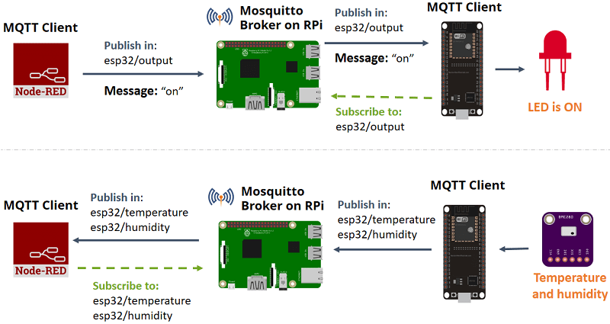

**The above figure shows the architecture of this exercise.**

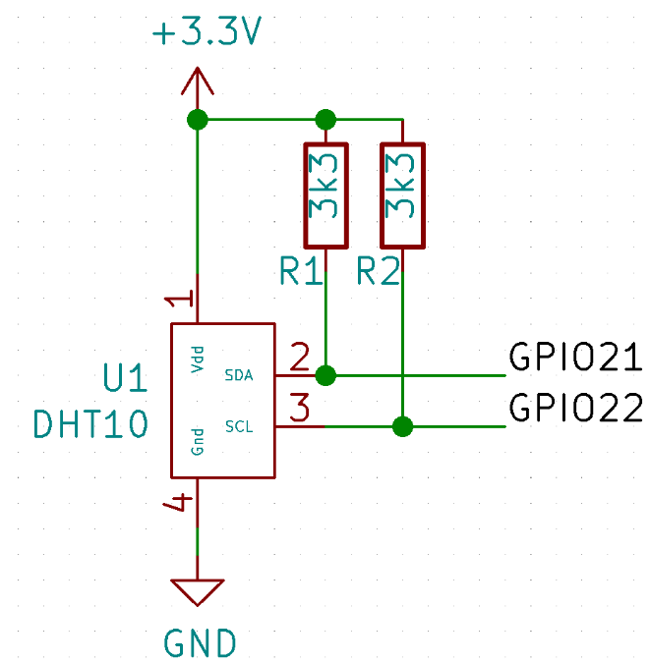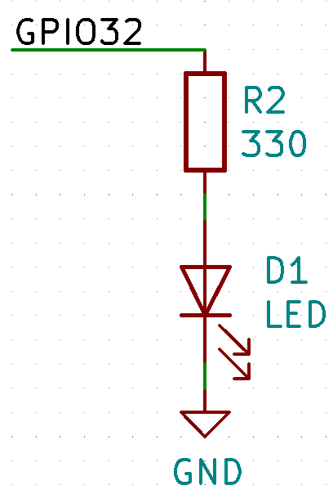

* 1. **Wire up the above circuit on ESP32.**
  2. **Upload** DHT10_LED_MQTT.ino **to ESP32. Do not forget to specify your Wi-Fi SSID, password and MQTT server IP address.**
  3. **Make sure that both your ESP32, RPi, and working laptop are in the same network, e.g. your mobile phone hotspot.**
  4. **Install and run MQTT broker according to the instruction** [**here**](https://randomnerdtutorials.com/how-to-install-mosquitto-broker-on-raspberry-pi/)**.**
  5. **Install and run NodeRED according to the instruction** [**here**](https://nodered.org/docs/getting-started/raspberrypi)**.**
  6. **Copy and paste the following NodeRED flow to your NodeRED (Import -> Clipboard).**

[{"id":"9e58624.7faaba","type":"mqtt out","z":"c02b79b2.501998","name":"","topic":"esp32/output","qos":"","retain":"","broker":"10e78a89.5b4fd5","x":610,"y":342,"wires":[]},{"id":"abf7079a.653be8","type":"mqtt in","z":"c02b79b2.501998","name":"","topic":"esp32/temperature","qos":"2","broker":"10e78a89.5b4fd5","x":484,"y":249,"wires":[["cc79021b.9a751","21eae8f8.2971b8"]]},{"id":"83cf37cf.c76988","type":"ui_switch","z":"c02b79b2.501998","name":"","label":"Output","group":"61285987.c20328","order":0,"width":0,"height":0,"passthru":true,"decouple":"false","topic":"","style":"","onvalue":"on","onvalueType":"str","onicon":"","oncolor":"","offvalue":"off","offvalueType":"str","officon":"","offcolor":"","x":469,"y":342,"wires":[["9e58624.7faaba"]]},{"id":"cc79021b.9a751","type":"debug","z":"c02b79b2.501998","name":"","active":true,"tosidebar":true,"console":false,"tostatus":false,"complete":"false","x":681,"y":216,"wires":[]},{"id":"4aecba01.78ce64","type":"mqtt in","z":"c02b79b2.501998","name":"","topic":"esp32/humidity","qos":"2","broker":"10e78a89.5b4fd5","x":473,"y":133,"wires":[["22efa7b7.544a28","df37e6b7.64c1c8"]]},{"id":"22efa7b7.544a28","type":"debug","z":"c02b79b2.501998","name":"","active":true,"tosidebar":true,"console":false,"tostatus":false,"complete":"false","x":670,"y":100,"wires":[]},{"id":"21eae8f8.2971b8","type":"ui_chart","z":"c02b79b2.501998","name":"","group":"61285987.c20328","order":0,"width":0,"height":0,"label":"Temperature","chartType":"line","legend":"false","xformat":"HH:mm:ss","interpolate":"linear","nodata":"","dot":false,"ymin":"","ymax":"","removeOlder":1,"removeOlderPoints":"","removeOlderUnit":"3600","cutout":0,"useOneColor":false,"colors":["#1f77b4","#aec7e8","#ff7f0e","#2ca02c","#98df8a","#d62728","#ff9896","#9467bd","#c5b0d5"],"useOldStyle":false,"x":681,"y":276,"wires":[[],[]]},{"id":"df37e6b7.64c1c8","type":"ui_gauge","z":"c02b79b2.501998","name":"","group":"61285987.c20328","order":0,"width":0,"height":0,"gtype":"gage","title":"Humidity","label":"%","format":"{{value}}","min":0,"max":"100","colors":["#00b3d9","#0073e6","#001bd7"],"seg1":"33","seg2":"66","x":660,"y":160,"wires":[]},{"id":"10e78a89.5b4fd5","type":"mqtt-broker","z":"","name":"","broker":"localhost","port":"1883","clientid":"","usetls":false,"compatmode":true,"keepalive":"60","cleansession":true,"birthTopic":"","birthQos":"0","birthPayload":"","closeTopic":"","closeQos":"0","closePayload":"","willTopic":"","willQos":"0","willPayload":""},{"id":"61285987.c20328","type":"ui_group","z":"","name":"Main","tab":"e7c46d5e.a1283","disp":true,"width":"6","collapse":false},{"id":"e7c46d5e.a1283","type":"ui_tab","z":"","name":"Dashboard","icon":"dashboard"}]

**Then you should get the following flow.**

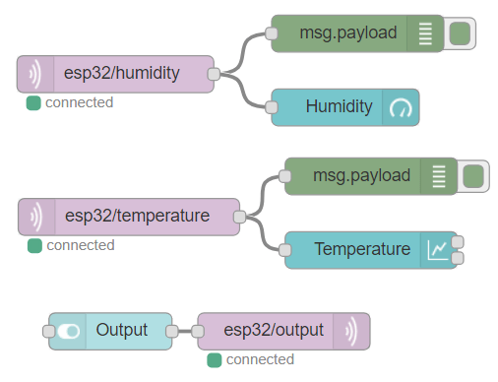

* 1. **Deploy your flow then capture your finished dashboard and put it below.**

